|  |  |  |
| --- | --- | --- |
| C:\Users\randy\MyWebSite\astronomy\img\SpringSkyTour.gif | Spring Sky TourRandy Culp | C:\Users\randy\MyWebSite\astronomy\spring.gif |

As the earth swings about the sun toward the northern face of our galaxy, we find ourselves looking out into deep space -- we are past the bright stars of winter into a fainter portion of the sky. With fewer bright stars, though, comes an abundance of deep sky beauties. If ever there is a time to bring out the largest aperture telescope you can get, the time is now.

The account here is the agenda that I loosely follow in providing a guided tour of the spring skies as visible from 45° North Latitude. This tour is designed for one topic to lead to the next, so it flows nicely and still manages to teach Astronomy under the night sky as we caravan from one constellation to another. Aside from the binoculars and telescopes I usually make a point of also bringing a highly focused flashlight which serves as an effective pointer for tracing out constellations.

Note that this tour is specifically designed to meet requirements 5, 7 and 8 (b) of the Astronomy merit badge, although of course there are lots of other tidbits here that go beyond the requirements of the badge.

Updated 14 April 2021

***View to the South***   
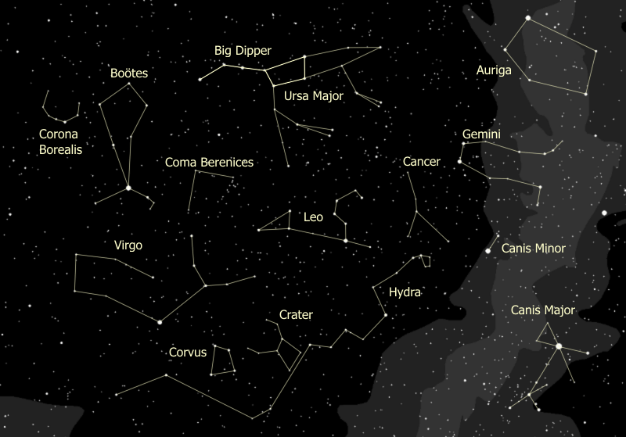

***View to the North***   
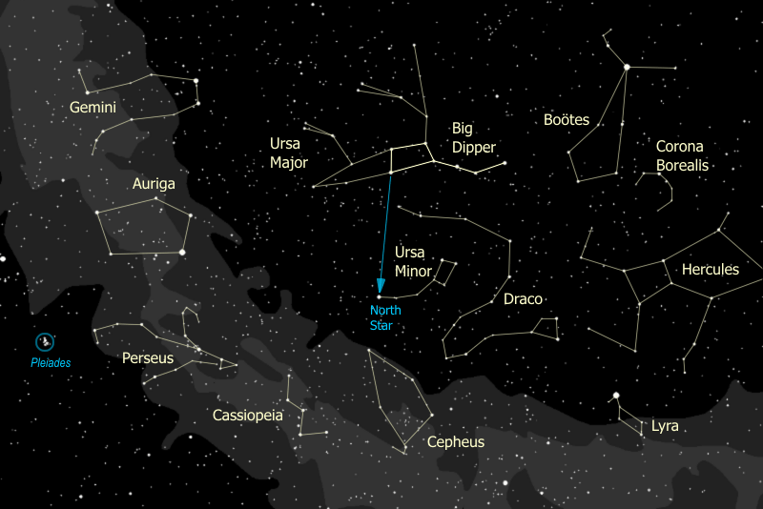

## Index to the Tour

C:\Users\randy\MyWebSite\astronomy\img\star.gif[Retreat of the Winter Titans](#_Retreat_of_the)  
C:\Users\randy\MyWebSite\astronomy\img\star.gif[Polar Constellations](#_The_Polar_Constellations)   
C:\Users\randy\MyWebSite\astronomy\img\star.gif[Auriga](#_The_Constellation_Auriga)   
C:\Users\randy\MyWebSite\astronomy\img\star.gif[Gemini & Cancer](#_Gemini_the_Twins)   
C:\Users\randy\MyWebSite\astronomy\img\star.gif[Hydra, Crater, & Corvus](#_Hydra_the_Sea)  
C:\Users\randy\MyWebSite\astronomy\img\star.gif[Virgo](#_The_Constellation_Virgo)  
C:\Users\randy\MyWebSite\astronomy\img\star.gif[Boötes & Corona Borealis](#_The_Constellation_Boötes)  
C:\Users\randy\MyWebSite\astronomy\img\star.gif[Leo & Coma Berenices](#_The_Constellation_Leo)

## Overview of the Tour

The Spring tour is unique, with the Big Dipper serving as the hub from which we guide our tour group through the entire parade of constellations. Starting with the pointer stars to Polaris, we then sweep generally West to East with the pointers to Auriga, then the pointers to Gemini then sweeping down through Hydra and Company to Virgo, then following the Dipper's handle (arc to Arcturus), and finishing with the pointers to Leo and Coma Berenices.

First, though, we will discuss the retreating winter titans -- Orion, Taurus, Canis Major, and Perseus. If they are fairly visible I might start with them, then go to the Big Dipper. This can be done in March and early April, although by May it's a lost cause. In particular -- I am trying to show off the Orion Nebula if looks reasonably good, as it is the last good diffuse nebula we will have until the Teapot of Sagittarius clears the trees.

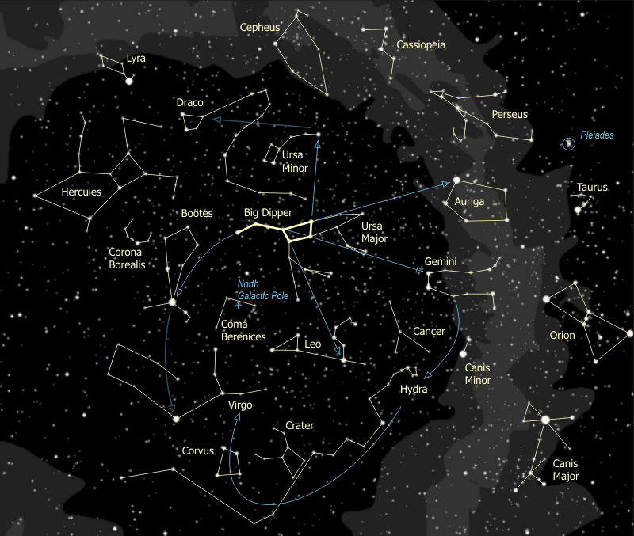

## The Top Attractions

Time might be limited, if it's chilly, if conditions are changing, or else if time is just limited. In that case, these are the best items to hit - the ones that the kids (and the adults) are talking about days later.

|  |  |  |  |
| --- | --- | --- | --- |
| **Feature** | **Naked Eye** | **Binoculars** | **Telescope** |
| Mizar & Alcor | ✓ | ✓ |  |
| The Beehive | ✓ | ✓ | ✓ |
| The Lost Star Cluster (M48) |  | ✓ | ✓ |
| The Eskimo Nebula |  |  | ✓ |
| Sombrero Galaxy |  | ✓ | ✓ |
| Arcturus | ✓ |  |  |
| M53 |  | ✓ | ✓ |
| Regulus & Gamma Leonis | ✓ | ✓ | ✓ |
| Black Eye Galaxy |  | ✓ | ✓ |

# Retreat of the Winter Titans

In March and early April we can still take advantage of the availability of the Great Orion Nebula as an example of a region of star birth. Past mid April, though, I just skip this and go on to the Big Dipper.

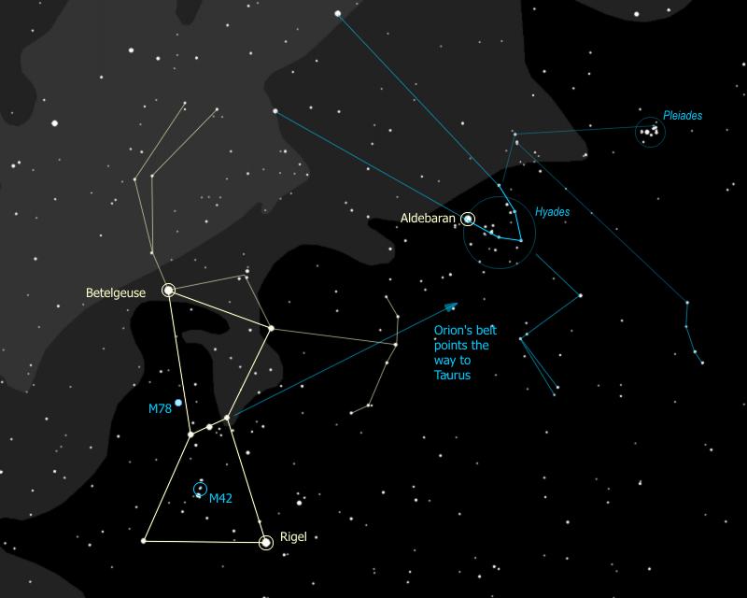

1. If Orion has not yet been lost to the horizon, our telescopes are set up and then are immediately trained directly on the Great Orion Nebula. So, now... as we all stare off into the West... who sees something they recognize? (Someone usually recognizes Orion.) This is the brightest constellation in the sky. Orion is a great hunter and mortal enemy of Scorpius, the Scorpion, which is why they are placed on opposite sides of the sky -- as we watch the last of Orion disappearing over the Western horizon we can turn and watch the head of Scorpius peaking above the eastern skyline to check that the coast is clear. When one rises the other sets, they are never seen together. {Trace out Orion, noting the belt, one raised arm holding a club, the other outstretched holding a pelt.}
2. The two brightest stars have their own names. The one at Orion's shoulder, to your left, is Betelgeuse, pronounced "beetle juice", yes, like the movie, and the one at Orion's knee, near the horizon, is Rigel. Do you notice anything special about Betelgeuse? See how red this star is? It is actually a red super-giant star. This star is enormous. Placed where our sun is, the surface of Betelgeuse would reach to somewhere between the orbits of Mars and Jupiter. It is so big that we have been able to make an image of it and measure its diameter even though it is about 500 light years away.

There is only one other red super-giant that is this bright and it's on the opposite side of the sky -- the Heart of the Scorpion -- the star Antares. Both stars are about 500 ly away in opposite directions so we lie about halfway between the two. Such stars are rare -- there are only 200 known red super-giants and all are much dimmer, and therefore much farther away than these two stars.

1. Notice that there's a sword that hangs from Orion's belt. See how the the sword gleams? That is not a trick of your eyes, there's something there, more than just a few stars. You can see it through binoculars, and you can see it better through the telescope.

|  |  |
| --- | --- |
| C:\Users\randy\MyWebSite\astronomy\img\m42_in_scope.jpg The Orion Nebula (M42) in a small telescope | C:\Users\randy\MyWebSite\astronomy\img\m42_FOV.jpg What you're actually looking at |

1. This is the Great Orion Nebula, considered by astronomers to be a "diffuse nebula"- a cloud of dust and hydrogen gas - the stars you see there were formed from the gas when it condensed together and compressed due to gravity then, under pressure, heated up and ignited. A nebula like this, then, is the birthplace of stars.
2. This region of the sky, Orion and its neighboring constellations, happens to be one that is dense with nebulae and young stars. The only other region of the sky with this much new-star formation activity is Scorpius & Sagittarius -- the opposite side of the sky.
3. This nebula is remarkably clear in a telescope, binoculars, or even to the fiercely concentrated eyeball. The longer you look, the more detail you can see. Notice in the telescope how the nebula forms the shape of a ghostly bat. Look very carefully at the bright star at the center of the nebula. It's not just one star, it is actually FOUR! In fact these four stars have a special name, they are called "The Trapezium". It is their energy that lights up the nebula.
4. The Great Orion Nebula is huge beyond comprehension -- what you are seeing is about 1500 light years away from us. The bright region you can see is about 5 or 6 light years across, however long-exposure photographs show that this nebula covers nearly the *entire constellation of Orion!*
5. You can extend the line of Orion's belt to the right toward a "V" of stars nearby. This is the face of Taurus the Bull. {Trace out Taurus, showing the face, the horns, and the two forelegs.} Some people try to fit the whole bull into the stars that are the legs and it comes out looking like something from a Picasso painting. That very bright star on the top left corner of the "V" is Aldebaran, pronounced "all-DEB-uh-ron".
6. 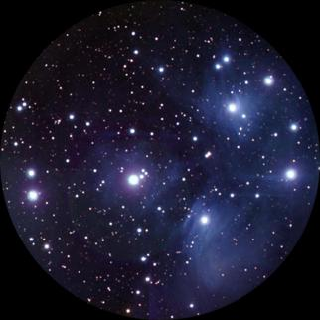See that little cluster of stars right about where the shoulder of the bull would be? That is the Pleiades, or the Seven Sisters. Can you count seven stars just by looking? Some people see six, some see seven. Actually you can find more than seven stars in binoculars and even more in the telescope. The better you can see this exquisite star cluster, the more beautiful it gets.

This is a true "galactic cluster", meaning a group of stars all born out of the same cloud of gas. Sometimes these are called "open clusters". In photographs of the Pleiades you can still see traces of gas around the stars, remnants of the original nebula. The Pleiades lie 400 light years away from us, with a total of 500 stars in the cluster. Nine are so bright they have their own names.

1. You want to see a star cluster that's three times closer than the Pleiades? The "Hyades" cluster is only 130 light years away from us. So where is the Hyades? It is the ENTIRE FACE OF THE BULL, with the notable exception of Aldebaran. Part of the reason that Aldebaran is so much brighter than the rest of the "V" is that it is only half as far away, at 65 light years.

Usually a star cluster looks like a tiny fuzz ball, but the Hyades appears to be a huge and distinct group of stars spread out over the sky because it's so close. Like the Pleiades, the group consists of about 400-500 stars total. Also like the Pleiades, this is a true galactic cluster, born from the same cloud of gas and all moving together in the same direction in space. They are moving away from us, toward Betelgeuse, and in 50 million years they'll be just another little fuzz ball near that star. So enjoy it now while you can. The Hyades is estimated to be about 400 million years old, making it a fairly old star group for an open cluster.

By comparison the Pleiades are much younger, at "only" 100 million years old. Galactic clusters usually are relatively young, since events conspire to break these groups up over time. The sun has long since left the nebula and cluster of its birth, travelling now through the galaxy alone, with only us to keep it company.

1. It's hard not to notice that really bright star to the South of Orion. That's not a planet, although it could pass for one. It's Sirius, the brightest star anywhere in the sky. It's called the Dog Star because it is actually the nose of the Big Dog, Canis Major. {Trace out Canis Major, showing two eyes, the nose, front legs, back legs & tail}. Some people see Sirius as the dog's collar, I prefer seeing the eyes & nose myself.

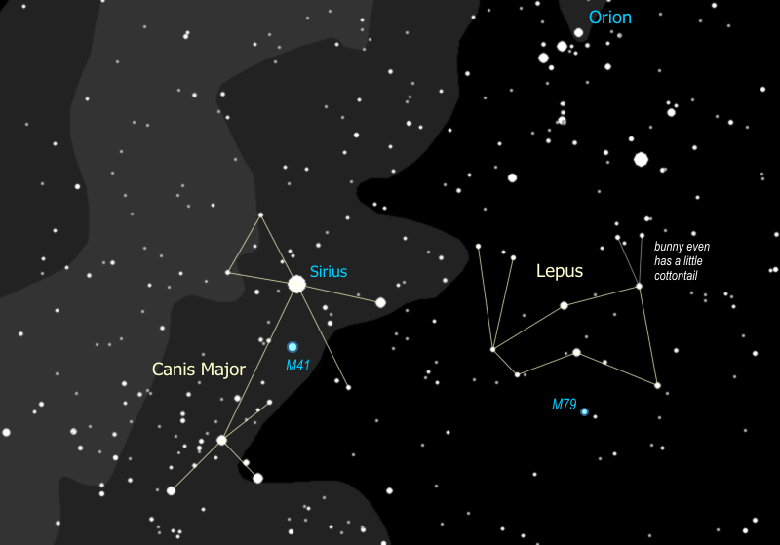

1. Of the stars you can see by eye, Sirius is the second closest, only about 9 light years away. Anyone know the closest? Yes, Alpha Centauri, which is 4 light years away, and can only be seen in the Southern hemisphere. Sirius is actually a double star. It has a white dwarf companion, a star that has blown off its outer envelope of gases and collapsed into a burning core that is about the mass of the sun packed into space about twice the diameter of the earth. A white dwarf is what our sun will eventually become. The companion can only be seen in the biggest telescopes, we can't see it with our little bitty one.

Lepus, of course, is lost to the horizon by now.

1. Above the Pleiades and to the North (off to the right) you see another grouping of bright stars. This is the constellation Perseus, representing the ancient Greek hero of the movie "Clash of the Titans". The triangle that forms his head, though of modest brightness, is an easy feature to recognize, then the rest of the figure, which is pretty bright, is easy to follow from there. {Trace out Perseus}. His right arm is holding his shield, and in his left hand he has the head of Medusa the Gorgon. Being a man of action, he comes directly from his triumphant victory over Medusa.

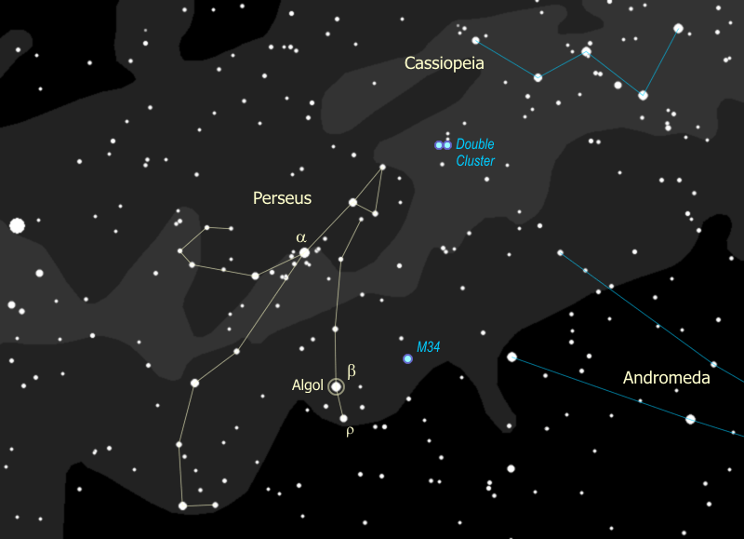

1. The eye of Medusa is well-represented by the star Algol {point out Algol}. Since ancient times Algol has been called the "Demon Star", and in fact the name means "head of the demon". Why? Because this star winks at you. Since stars aren't supposed to do that, it kind of gave people the willies long ago, and they figured it had to be evil or posessed or in some other way just wrong. Normally Algol is nearly as bright as a Persei {point out a}, almost exactly as bright as g Andromedae. Sure enough, just about every 3 days Algol drops in brightness to that of r Persei {point out r}. It stays like that for a few hours then goes back to being as bright as a. Any guesses why something like this might happen?

Algol is actually a binary star, and the orbit of the two stars is right in line with us, so each time one star passes in front of the other, the second one is blocked and we see only half the light. This is called an "eclipsing binary". This is not the same as a Cepheid variable, where the star itself is changing. So what do you think -- is Algol in eclipse right now? We will check on it again when we get the chance and see if we can spot the change.

1. If it seems to you that there are an awful lot of stars around a Persei that's because there are... that is a true glactic cluster of stars, like the Pleiades, all formed together. This group is just a little bit farther than the Pleiades and a little more scattered. They look spectacular in binoculars, with many very young, hot, blue stars (the cluster is about 50 million years old, about half the age of the also very young Pleiades).
2. You can spot another cluster in Perseus half way between Algol and g Andromedae -- an easy target for binoculars and with a really dark sky, one you should be able to spot just by looking. This is M34, about 1500 light years away and very similar in nature to the Pleiades or the a Persei moving group, about 100 million years old and just about 3 times as far away.
3. But the best cluster in Perseus is really two clusters, the Double Cluster halfway between Perseus and Cassiopeia. You can find it easily in the binoculars, and this is definitely worth getting in the telescope. The one closer to Cassiopeia called "h Persei" and is "only" about 6 million years old. The one closer to Perseus is called "c (chi) Persei" and is 12 million years old. How can you tell that c Persei is older? If you look at it carefully in the telescope you might be able to spot 3 red giants in c Persei, whereas h Persei has no stars old enough to have evolved yet into red giants.

|  |
| --- |
| Double Cluster with c Persei to the left and h Persei to the right |
| C:\Users\randy\MyWebSite\astronomy\img\doubleCluster2.jpg |

1. We've seen a very close star cluster, the Hyades, which at 130 light years is the second closest to us. So, then, what would be the *closest* star cluster? Let's take a look way to the North...

# The Polar Constellations

1. We officially start our tour of the Spring Sky by turning our attention to the North. Anybody recognize anything? (Someone will recognize the Big Dipper). {Trace out the Big Dipper}.

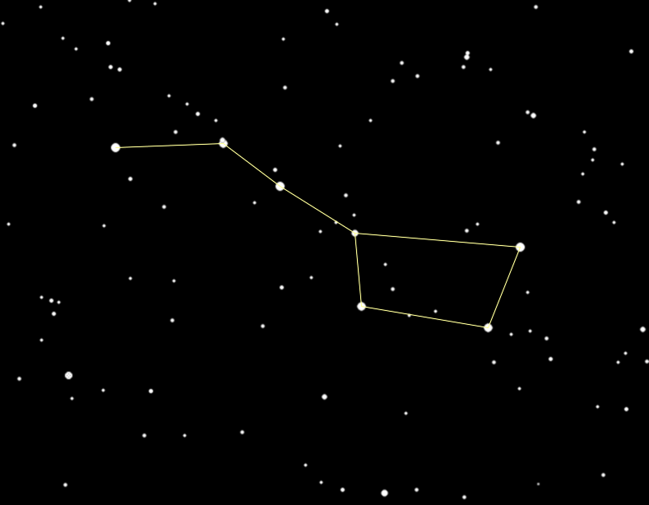

1. It's really not a constellation, it's what's called an 'asterism', a highly recognizable part of a constellation. The full constellation actually is Ursa Major. {Trace out the full constellation of Ursa Major.}
2. The Bear's paws are also known as the Three Leaps of the Gazelle. This asterism is the sequence of three pairs of stars - normally seen as the paws of Ursa Major. The story is that Leo the Lion startled a gazelle, who in turn dashed off across a great celestial pond, leaving a pair of stars marking each of the three leaps.

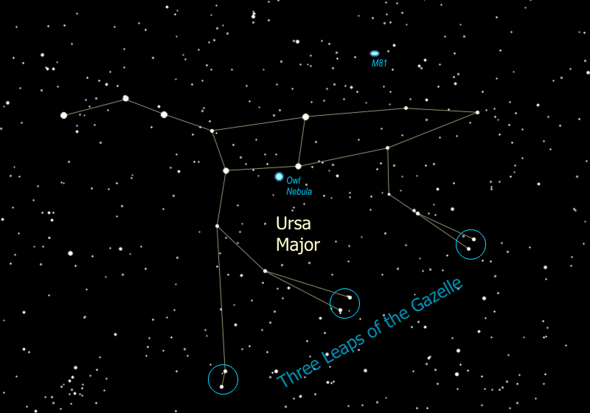

1. The stars of the Big Dipper, with the exception of the tip of the handle and the tip of the cup, are all moving in the same direction -- up and to the left, or toward the Northwest. Because they're close together (all are about 75 light years away) and moving through space in the same direction at the same speed, these stars are believed to have formed together from the same original nebula. This group, known as the "Ursa Major Moving Group", is officially the closest star cluster to us, and includes stars that are scattered across the sky all the way from Boötes & Corona Borealis to Auriga and Taurus. The reason they seem to be everywhere is because our 5 billion-year-old sun has drifted into the outer regions of this group of 500 million-year-old youngsters.
2. We can find two of the best and brightest galaxies in the sky just above the two stars that form the neck of the Bear -- they are M81 and its neighbor M82. Use the binoculars and follow the line of the Bear's neck to a skinny triangle, then go sideways to find a pair of stars that point the same direction as the triangle does. Just a little farther you find M81, a faint fuzzy spot just off the end of the arc of three faint stars nearby. See it? This faint fuzzy spot is actually a spiral galaxy, 12 MILLION light years away. When I get this one in the telescope you'll see that there are actually two galaxies there. The other one is M82, and it's called the Cigar Galaxy because of its shape -- it looks flatter than M81 because we're seeing it edge-on. M82 is about the same distance as M81, and is called a "starburst galaxy", because the gravity from M81 is causing a burst of new star formation in the Cigar. So even though M82 is only about a third the size of our Milky Way galaxy, it is five times brighter!

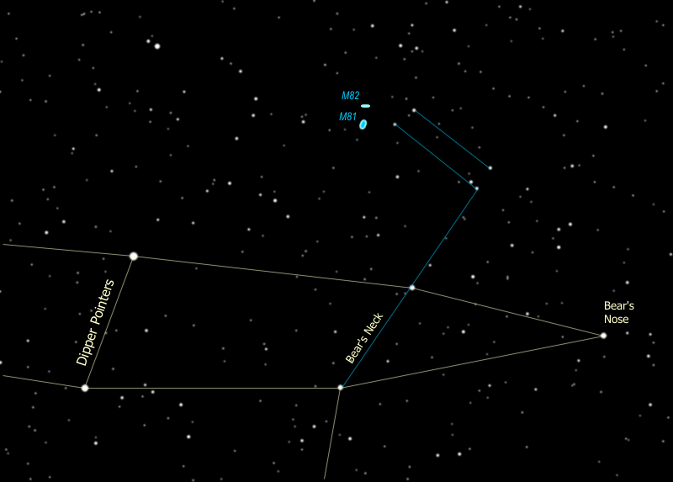

|  |
| --- |
| M81 is on the left, M82 is at the right |
| C:\Users\randy\MyWebSite\astronomy\img\m81m82.jpg |

1. The Big Dipper is a polar 'constellation' -- one that is very close to the North Pole. If stars are close enough to the pole they never set below the horizon and we can see them all year long. Can anyone spot the Pole Star? How do you find it? That's right, the two stars at the front edge of the cup are pointer stars and point to the North Star, whose actual name is Polaris. Go up from the cup to find Polaris.

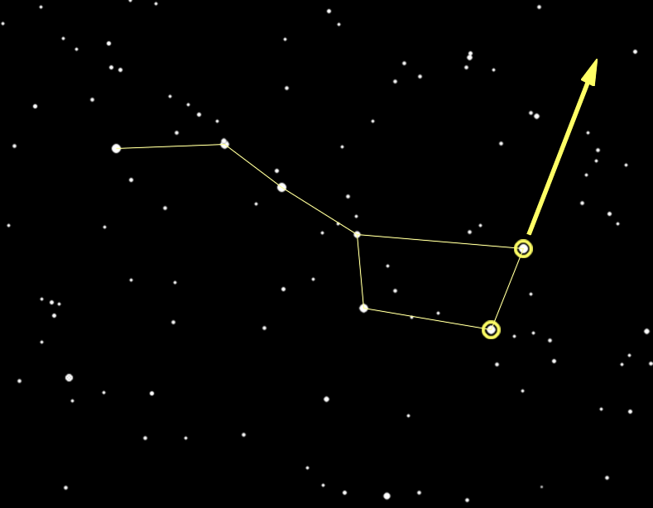

1. Since the earth's north pole points to Polaris and the earth rotates around its poles, all the constellations seem to rotate around Polaris, including the Big Dipper. You can tell time using the Big Dipper -- it serves as a 24-hour clock.

Click on the little clock [here [C:\Users\randy\MyWebSite\astronomy\img\tt32.gif](#_Tell_Time_by)](#_Tell_Time_by)for more information.

1. Polaris is a part of the constellation Ursa Minor, more commonly known as the Little Dipper. Polaris is at the tip of the handle. {Trace out the Little Dipper.}

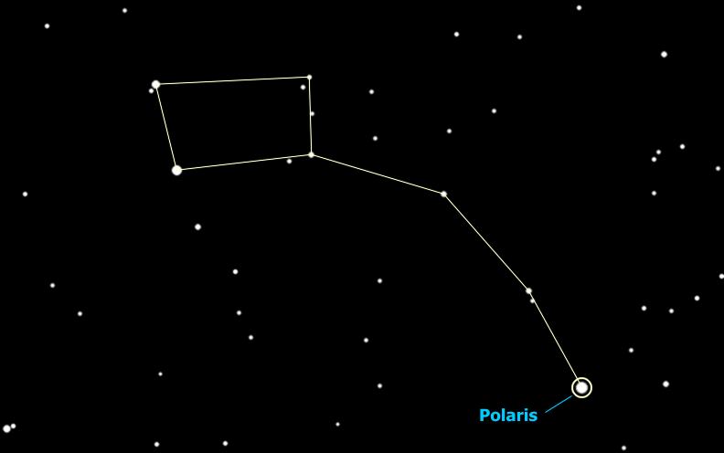

1. Threading his way between the Big Dipper and the Little Dipper is Draco the Dragon. {Trace out Draco.} Draco starts off with two bright yellow eyes (actually one's yellow, one's orange), and then winds around the little dipper with its tail between the two dippers. This is a very cool-looking constellation, a rare one that looks like the monster it is supposed to be, glaring yellow eyes and all. The head of Draco forms a distinct asterism, known as "The Lozenge". Who's got the binoculars? Use them to find Draco's eyes, then go down to find the next star in the Lozenge closest to the eyes -- ν (nu) Draconis. Notice anything? That's right, it's a double star, and a very neat one in binoculars, tight together and exactly equal in brightness.

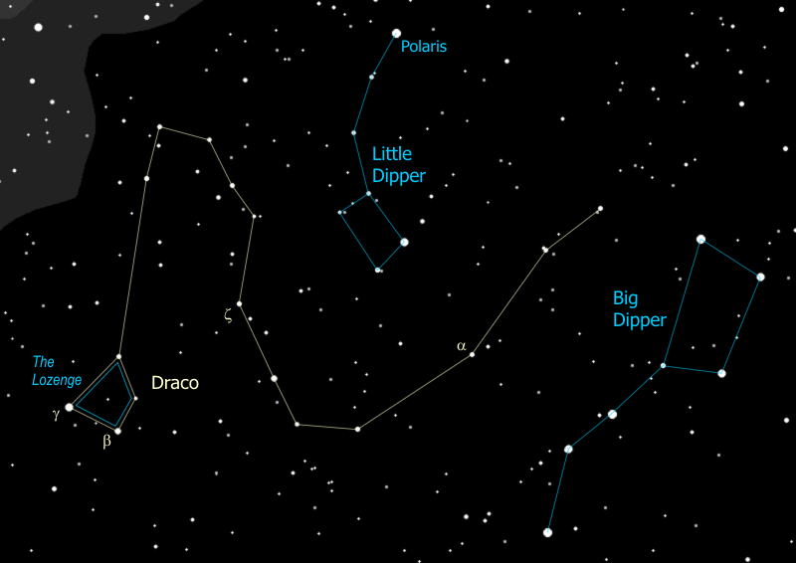

1. So the Big Dipper points to the North Star -- it also points to other important stars -- in fact it points us to all the important constellations we visit tonight. You can follow the two stars across the top of the cup and they lead you to the northernmost bright star Capella, in the constellation Auriga. If, instead of going up from the front of the cup, you go down from the back of the cup, you end up at the star Regulus in the constellation Leo. And... if you go across the cup, from the back top to the bottom front, you end up at Castor in Gemini. You can continue that line on until you get to Betelgeuse in Orion, the brilliant red star to the west. We'll come back and hit each of these one at a time.

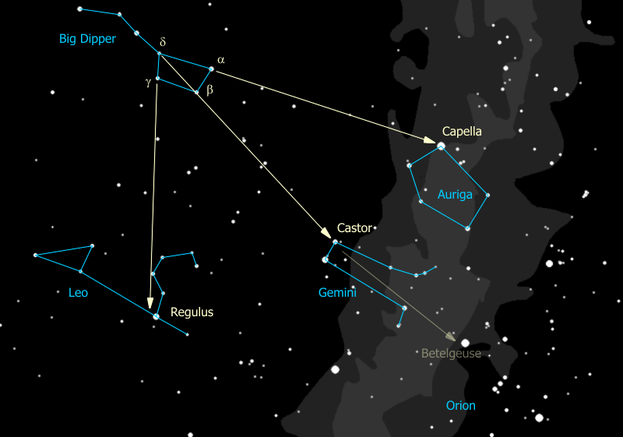

1. The three stars of the dipper's handle are pointers as well -- you follow the arc of the Dipper's handle and "arc to Arcturus", then "spike to Spica" - two very important stars that we will get to presently.

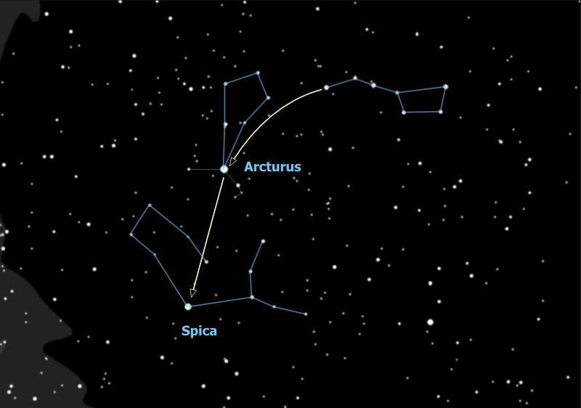

1. Wait a minute is that really three stars in the Dipper's handle or is it four? Looky there the middle star seems to have a companion -- the bright star is Mizar and the companion is Alcor. Who can see the companion?

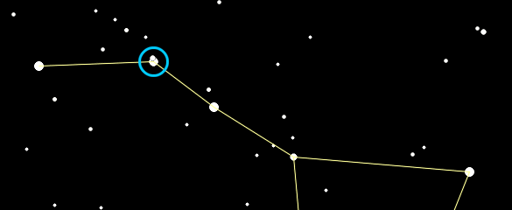

That was used by ancient Greek and Arab armies as an eye test. Some see them as a horse & rider. The Europeans saw the handle of the dipper as the tail of the Great Bear. Since bears don't have tails they danced around it by explaining that when the gods lifted the bear to the sky the tail got stretched out. Pretty lame. The Indians, who knew darn right well that bears don't have tails, saw the three stars of the handle as hunters chasing the great bear (interesting that they also saw a bear). When the constellation Ursa Major sets in the fall, the Indians explained that the hunters catch up with him and shoot him with their arrows, which is why the leaves on the trees turn red. Anyway the three stars are hunters and one of them brought his dog, so Mizar is a hunter and Alcor is his dog. Or another story is that there are three hunters pursuing the bear and one brought a pot to cook the bear in (optimistic). So Mizar is a hunter and Alcor is his pot. Yet another story involves the Pleiades. This is a star cluster in the constellation Taurus (a winter constellation). It is called "the Seven Sisters" and those with very sharp eyes can see seven stars but most people can only see six. So the story is that Mizar is riding off with the Seventh Sister.

But wait there's more! When we put the telescope on these two you'll see that Mizar is really a double star itself! So these three form a triple star. But wait... that's right... there's MORE! In reality each of the two stars that make up Mizar is a double star, too close for us to see even with a big telescope, and for that matter, so is Alcor! So Mizar & Alcor comprise a SIX STAR SYSTEM!!

# The Constellation Auriga

We now will follow the two stars across the top of the cup of the [Dipper](file:///C:\Users\randy\MyWebSite\astronomy\Spring\Polar.html#Pointers) and cruise westward to the star Capella in the constellation Auriga.

1. Auriga forms a distinctive five-sided figure, and to do so it actually borrows a star -- β (beta) Tauri which marks the tip of the Bull's northern horn. {Trace out Auriga}

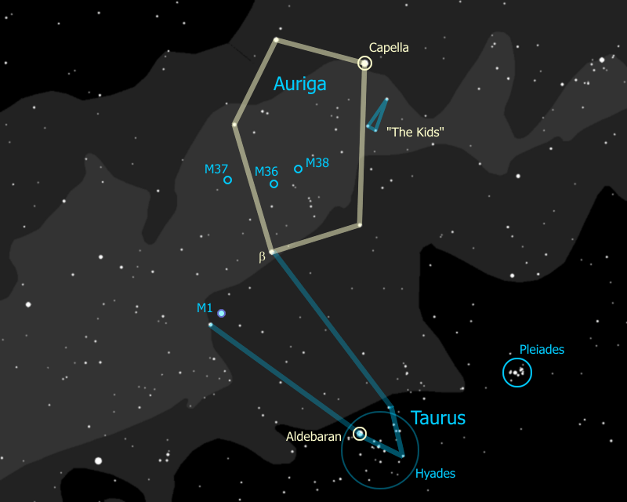

Auriga is often shown seated and holding a young goat in his arms, represented by the small thin triangle of stars along the right side of the pentangle. These stars are known as "The Kids". The star at the tip of this triangle is ε (epsilon) Aurigae. This is one of the brightest stars in our galaxy, a huge star 2,000 light years away which, every 27 years, is eclipsed by something even huger -- eclipsed for two full years.

The mystery of how this happens may have been solved very recently -- in January of 2010 the theory was presented that ε Aurigae is a dying star, with twice the mass of the sun and blown up to 100 times the diameter of the sun, whose outer shells are being blown off, captured, and formed into a disk by an orbiting companion star. It is this disk, which we are seeing edge on, that is periodically dimming ε Aurigae.

|  |
| --- |
| Artist's Conception of Epsilon Aurigae in Eclipse |
| C:\Users\randy\MyWebSite\astronomy\img\Epsilon_Aurigae_small.jpg |

1. The brightest star in Auriga is "Capella". Part of the reason it's so bright is because it's pretty close, 45 light years away. That makes it a little less than half the distance to the Hyades cluster. In fact, it is moving in space at the same speed in the same direction as the Hyades, and may be an "outlier" of that group. Another reason it's so bright is that it is really two stars orbiting one another, too close for us to see in the telescope. Capella is an important star for navigation because it's among the brightest stars in the sky, and because it's so far north that you can see it nearly all year round.
2. The star at Auriga's head, the bright one to the left of Capella, is a member of the Ursa Major Moving Group.
3. Note - we might have the following discussion any time during the sky tour, whenever it comes up.

Auriga lies right across the Milky Way and therefore contains lots of interesting stars and star clusters. Someone want to tell me what that means -- "The Milky Way"? Where is the Milky Way (someone will always point it out). Most people recognize the Milky Way as a band of light across the night sky, but what is that band of light - where does it come from?

Well it's a bit like looking at a gravel road. Close to you, you can see individual stones, while off in the distance the road merges into a uniform gray. When you look at the Milky Way you are looking at the disk of our galaxy from the inside - the nearby stars you can see individually (most are less than 1,000 light years away), the distant stars merge into a hazy glow. So when you see that band across the sky you are really looking way off into the distance, into the "billions and billions" of stars that make up the disk of our galaxy.



You'll see a similar phenomenon when we look at the more distant galactic clusters. Through binoculars you see them as a hazy patch. When you see them through a telescope - that is, closer up - you can pick out individual stars. The better the telescope, the 'closer' you can get to the cluster, the more stars you can see.



1. Because it is the disk of our galaxy that we are seeing, from the inside, that band of light across the sky is really a hoop -- arcing over us, diving down below the South horizon, circling around beneath us and coming back up in the North sky. This side of the hoop has shifted over to the Western sky and is sweeping toward the horizon. That means that as we look up in that direction (I'm pointing directly at 31 Comae Berenices) we are looking out of the disk of our galaxy. And what do we see as we look out of our galaxy, into outer space, across vast distances? Of course -- other galaxies. Hundreds of them. Thousands of them. That region right there (my pointer is sweeping the sky from Corvus to the Dipper) is Galaxy Alley, and we will get a chance to see at least a few of those other galaxies tonight.

# Gemini the Twins

1. We now return to the [Dipper](file:///C:\Users\randy\MyWebSite\astronomy\Spring\Polar.html#Pointers) and follow the two stars diagonally across the cup southwest to the star Castor. This is part of the Zodiac Constellation Gemini the twins. The two brightest stars are Pollux, to the left, and Castor, to the right. {Trace out Gemini}. At this time of the year, with Leo straight up overhead, the constellation Gemini stands above the western horizon, towering majestically, with the pentangle figure of Auriga to the right and the tiny but bright Canis Minor to the left, in very impressive fashion. Well, I'm impressed.

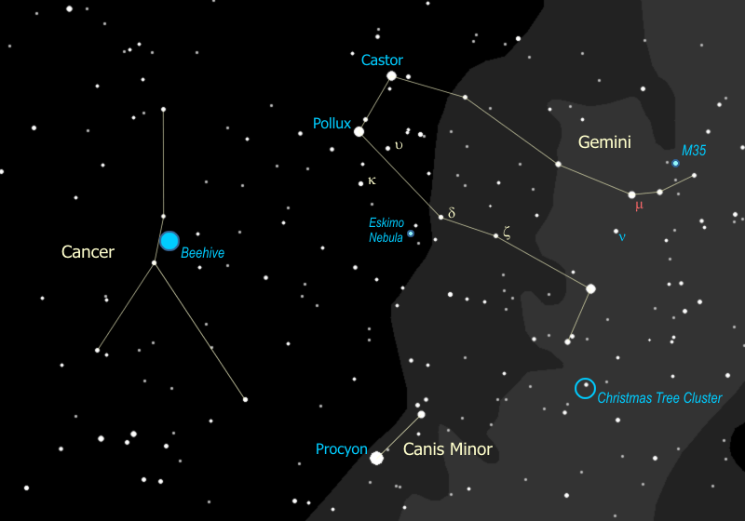

1. That really bright star right next to Gemini is Procyon, the "Little Dog Star" a mere 12 light years away, and belongs to the constellation Canis Minor, the Little Dog, which is all of those two stars right there {Point out Canis Minor}. The little dog belongs to Orion the great hunter, as does the Big Dog.
2. The discovery of a planet orbiting Pollux in 2006 makes it one of the few naked-eye stars known to have a planet.

We can't see the planet in our telescope from 30-something light-years away, but we can see something else...

1. If we get Castor in the telescope at high magnification you can see it as a double star. In reality, each of those stars is a double, too close to see in our telescope, and then there is another, third (very faint) star that is also a part of the system which is ALSO a double. So while we can see two stars (at best) in our telescope, Castor is actually a SIX STAR SYSTEM, about 50 light years away.
2. Down by the foot of Castor (the twin), is the open cluster M35, a pretty darn good cluster either in binoculars or in the telescope. If we have a clear, dark night you may be able to spot it with your eyes alone. This is a true "galactic cluster", meaning a group of stars all born out of the same cloud of gas. Sometimes these are called "open clusters". This cluster is about 3,000 light years away and if you look carefully in a telescope, you can see another cluster right next to it... that one is about 16,000 light years or nearly six times as far away.
3. Since they're twins Pollux gets to have a cool cluster down by his foot too. If you look off the tip of the foot of Pollux you will see a line of three stars pointing to the southwest, toward Orion's belt. Put the binoculars on the first of those three stars (closest to Pollux's foot) and you will see the Christmas tree cluster. The star you saw is the base of the tree, and the rest of the tree is hanging upside down from the base. Photographs of that region show a fascinating complex of gas clouds (nebulae) around those stars.

|  |  |
| --- | --- |
| M35 is easy to see in binoculars | The Christmas Tree is upside down (North is up) |
| C:\Users\randy\MyWebSite\astronomy\img\M35.gif | C:\Users\randy\MyWebSite\astronomy\img\ChristmasTree.gif |

1. If we follow the line from Pollux' foot toward Pollux the star, you come across the star d Geminorum. Next to that star there is a small triangle of stars, {point out 56, 61, & 63 Geminorum} and that's where we are moving the telescope next. When you look in the eyepiece you'll see a faint star and something else... a little fuzzy spot. The fuzzy spot is actually a star like the one next to it, with one small difference... the star has blown itself apart! This little puff is known as the Eskimo Nebula, also called the Clown Face Nebula. If we have a big enough telescope you can see what's left the star at the center, a once mighty star that is now a white dwarf. With a really good telescope we can see the Clown's (or Eskimo's) face, with the star at the center making a clown's nose for us.

|  |  |
| --- | --- |
| Eskimo in Telescope - can you see his face? | What you're looking at (courtesy the Hubble Telescope) |
| C:\Users\randy\MyWebSite\astronomy\img\EskimoInScope.jpg | C:\Users\randy\MyWebSite\astronomy\img\EskimoInHubble.jpg |

1. This is called a "planetary nebula", because the disk shape suggested the look of a planet to early astronomers. In fact it has nothing to do with planets at all. This is what's left of a red giant star which, a couple thousand years ago, did what all red giants eventually do. When the fuel at the core runs so low that the nuclear reactions can no longer hold up the weight of the star, it all collapses in to the center, which in turn raises the temperature so high that the star blows off its outer envelope of gases, losing much of its mass. This exposes the core to outer space, or, more accurately, exposes outer space to the core. The intense radiation from the white-hot core causes the expanding shell of gas to light up like a neon light, and voila -- the faintly glowing disk that you see here. That little disk is about 3,000 light years away and 3 light years across - the diameter of it would reach nearly from here to Alpha Centauri.
2. I once heard planetary nebulae described as the wreaths that Nature places around dying stars.
3. I called Gemini a Zodiac constellation. What is a "Zodiac" constellation?

As the earth goes around the sun, this motion means that every day we look back at the sun in a slightly different direction, with different stars behind it. The sun appears to move through the constellations. Theoretically there are twelve constellations through which the sun moves, one per month, and these are the Zodiac constellations. In reality there is a 13th constellation through which the sun passes (technically at least) and it gets no credit for being in the Zodiac - Ophiuchus. Because the path of the sun is also the plane of our solar system, the planets are also found on or very close to this path as well, so the line along which the sun travels has its own special name - it's called the "ecliptic".

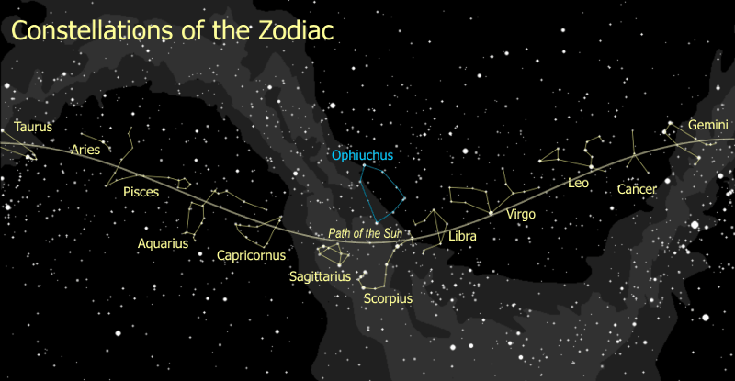

1. So Gemini is one Zodiac sign and those bright stars there are Leo the Lion, which we will explore shortly. Between these two bold and brilliant Zodiac constellations is yet another Zodiac sign -- seemingly shy and trying to hide between the other two -- the ever so faint Crab with the unfortunate name of "Cancer". {Trace out Cancer the Crab} My real target here is the Beehive, and in some cases I don't bother with Cancer at all -- I simply tell the group to look halfway between the bright stars of Leo and the bright stars of Gemini -- in the center of the dark region is a faint fuzzy spot. Most people will see it right away.
2. It's so unremarkable I wouldn't even bother showing you this constellation, except for one thing... the Beehive. If you look very carefully at the center of the crab, you will see a faint hazy patch. Now look at that hazy patch through the binoculars. Wow, eh? That's the Beehive Cluster, about 500 light years away, six times closer than M35 is.

|  |
| --- |
| The Beehive is so big you can see it just by looking |
| C:\Users\randy\MyWebSite\astronomy\img\Beehive.gif |

# Hydra the Sea Serpent

1. Just below the barely discernable figure of Cancer the Crab is a fairly distinct grouping of about six stars. You are looking at the two eyes, the two nostrils, and the two stars that begin the neck of the longest and largest constellation in the entire sky, Hydra the Sea Serpent. {Trace out the entire length of Hydra}

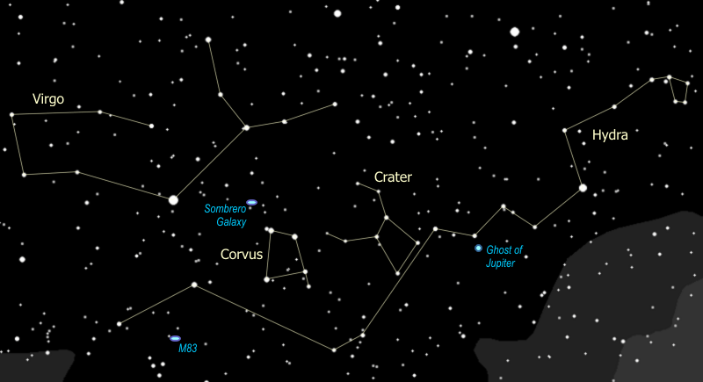

1. Now if you look halfway between Hydra's head and the star Procyon and go south to form an equilateral triangle with those two, you see a small triangle of stars at that spot. Put the binoculars on that triangle and at its center you will find the Lost Star Cluster, M48. Charles Messier put this group on his list in 1771, and no one found it again for almost 200 years, because he wrote the location down wrong -- off by 4°.

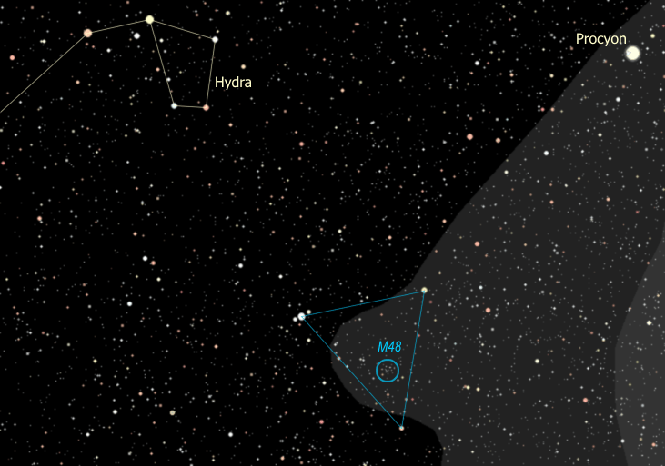

1. We now go from the head of the sea serpent and follow the undulating back, to the bright star that is the heart of the serpent, "Cor Hyrae". This star is more commonly known as "Alphard", The Solitary One, because it stands as the lone bright star in this otherwise empty part of the sky. So what do you think, is Alphard the brightest star in the sky right now? Do you see any stars you think might be even brighter? Certainly Procyon is brighter. Which do you think is brighter, Alphard or Pollux? How about Pollux and Capella, which do you think is brighter?

Astronomers measure star brightness using 'magnitudes' -- Capella has a magnitude of 0, Pollux has a magnitude of 1, Alphard has a magnitude of 2. As magnitude number goes up, brightness goes down. A magnitude 1 is 2½ times as bright as a magnitude 2, a 2 is 2½ times as bright as a 3, and so on.

This comes from the system set up by ancient Greeks, where the brightest stars were stars of the first magnitude, like 'first class', and the faintest stars you could see were stars of the sixth magnitude. When astronomers got telescopes and instruments that could measure star brightness, they found 1st magnitude stars were almost exactly 100 times the brightness of 6th magnitude stars. That works out to a factor of 2½ from one magnitude to the next.

Magnitudes can go negative for stars brighter than 0 magnitude Capella. Sirius, the brilliant winter star that is now setting on the western horizon, is the brightest star anywhere in the sky (any time of the year) with a magnitude -1.5.

Well, what's really the brightest star in the sky? The sun has a magnitude of -27.

1. It's not only the brightness of each star that is different. Look at Castor and Pollux. Can you see a difference in color between these two stars? Castor is white, and Pollux is more yellow or even orange. Now let's look at those two stars down by the feet of Castor (the twin). {Point out n (nu) and m (mu) Geminorum}. It is probably easier to compare them using the binoculars. How would you describe the color difference of those two? One of them is very red, and the other is... blue, isn't it? What color would you call Alphard? Pretty red, isn't it? So what do the star colors mean? Why would one star be blue and another red?

Yup, that's right. Different colors show different temperatures. So which star color is the hottest? Just like a flame, blue is the hottest part, yellow is next, red is the coolest. The sun is a yellow star, about 10,000°F at the surface. A red star is about half the sun's surface temperature, whereas a blue star is three to five times as hot as the sun. White stars like Sirius are somewhere between the yellow ones and blue ones.

Now, all stars are made of pretty much the same stuff -- about 90% hydrogen and the rest is helium with some traces of other stuff. So, why would one star be burning hotter than another? The answer is in the size of the star. The more massive it is, the more pressure there is at the center and therefore the hotter - and for that matter the brighter - the star burns. So blue stars are the biggest and brightest of stars, and red stars are the smallest and dimmest.

So why is red Alphard so bright? Hmmm... yeah... well, like with most rules, there are exceptions to the rule, and this rule is no exception. Alphard is a star that is literally running out of gas. As a star burns up all the hydrogen at its center, it starts to burn helium (which is the "ash" from the hydrogen burning), which makes it expand, get brighter, and turn red -- it becomes a red giant. This is the time you can get a bright red star, when the star is near the end of its life.

When our sun starts burning out it will expand so big it will swallow up Mercury and Venus and scorch the surface of the earth to a cinder. If you are hoping to see all that happen you will have to wait about 5 billion years.

So there are two reasons a star could be red -- it is massive (and once was yellow, white or even blue) and is now burning out (a red giant), or it never had enough mass to burn any hotter than red (a red dwarf).

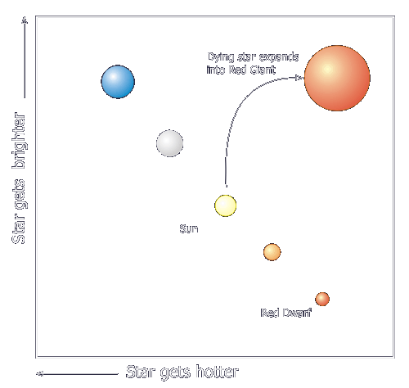

Notice that when we graph out the stars showing their temperature (or color) against their brightness, most of them fall along a line -- this line is called the Main Sequence, and the graph is called the "H-R" (for Hertzsprung-Russell) Diagram. Others are not on the main sequence, mostly stars that are either just being born (called "T-Tauri" stars) or stars that are near the end of life.

1. Let's continue on along the back of the sea serpent, through the dip of the first coil and we will stop at the bottom of the second coil. We are going to direct our telescope right there, looking for the Ghost of Jupiter. This is another planetary nebula -- a "wreath around a dying star", like the Eskimo Nebula. Look carefully and you can see the central star that is powering the lights on this glowing disk.

|  |  |
| --- | --- |
| Ghost of Jupiter in Telescope | What you're looking at |
| C:\Users\randy\MyWebSite\astronomy\img\GhostInScope.jpg | C:\Users\randy\MyWebSite\astronomy\img\GhostOfJupiter.jpg |

1. As we continue down the sea serpent's back we come across two other constellations - literally riding the back of Hydra. The first one is called "Crater", it's supposed to be a cup and you can actually see it, although admittedly it looks like it's been dropped more than once. {Trace out Crater the Cup}
2. Following right behind Crater is that much brighter, odd-shaped square, or kind of a trapezoid. This is the constellation "Corvus" and it's supposed to be a Crow. Don't see a crow? Try this - the two top stars of the trapezoid are each a wing tip (he's holding them up), his body is the line of stars across the bottom, and his head is the star below the trapezoid on the right. Still don't see a crow? Nah - neither do I.

So why is it a crow if it doesn't look like one? Well, it fits with an ancient fable wherein Apollo gives a crow his cup and sends him for water (he's a god - he can send a bird to get water for him... in a cup... and somehow it's supposed to work out). Well the crow stopped to eat some figs -- well, actually, he waited for them to *ripen* first -- so he came back really late. He tried to get out of it by telling Apollo that a serpent held him up, but Apollo wasn't fooled, so he placed the crow and the cup in the sky along with the serpent, with instructions to the snake to keep the cup just out of the crow's reach.

1. Ok. So maybe we can't see a crow, but we can see a galaxy - two if we are lucky, and these are very cool-looking ones. I'm setting up the telescope to look at the Sombrero galaxy, on the southern edge of the band of galaxies that stretches across the center of the spring sky. The disk of this galaxy is very clearly defined and rimmed with a dark ring of dust. It is nearly edge-on to us, and tilted slightly so that the dome of the galaxy core is clearly visible. All this gives the galaxy the look of a Mexican hat -- hence the name. You are looking across 40 million light years of space (and 40 million years back in time) when you see this galaxy, a member of the Virgo cluster of galaxies that we will discuss momentarily.
2. If we have the time, the conditions, the equipment (a pretty good telescope), and the inclination we will continue on a galactic pursuit by moving the scope down to M83 -- just south of the end of Hydra's tail. While the Sombrero is an edge-on galaxy, this one is an exquisitely beautiful face-on spiral. Seeing the graceful spiral arms of this galaxy, though, requires a telescope of about 12" diameter. On those rare occasions that you have such a scope (or bigger) on hand, and a dark, clear night, this is what to do with it. M83 is about 10 million light years away and is known among astronomers for producing supernovae - about one every 10 or 15 years, where most galaxies get one per 300 years.

|  |  |
| --- | --- |
| The Sombrero Galaxy from the Hubble Telescope | The magnificent spiral galaxy M83 |
| C:\Users\randy\MyWebSite\astronomy\img\Sombrero.jpg | C:\Users\randy\MyWebSite\astronomy\img\M83.jpg |

# The Constellation Virgo

1. We now continue up to that very bright star just above Corvus. This is the star Spica -- it is exactly magnitude 1.0, and it's not really all that close, being 275 light years away. It turns out this star is more than two *thousand* times as bright as our sun. See how blue it is? That is the sign of a bright, fast-burning star.

Even though it's ten times as massive as our sun, Spica will burn itself out in less than 5% of the time our sun will live, because it's burning its fuel up so fast. That means that this star was probably born around the time that dinosaurs appeared on earth, a cosmic blink of the eye ago, and will burn out in about that much time again. Meanwhile our sun, ten times smaller, and born five *billion* years ago, just keeps on burning. So it goes with stars - the bigger they are, the harder they fall.

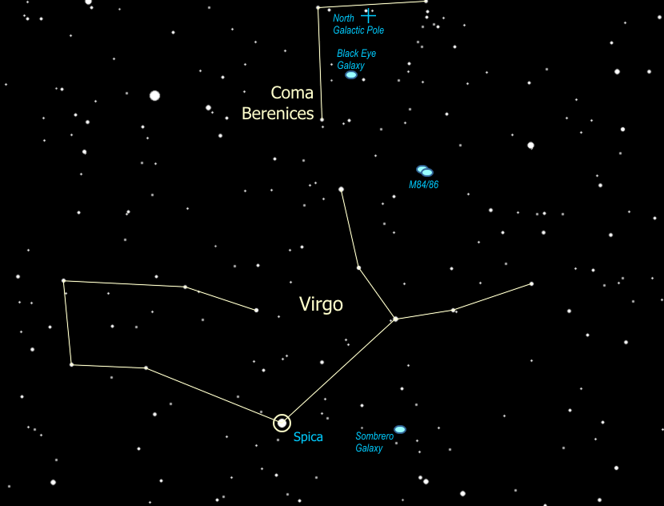

1. Spica is part of the Zodiac constellation Virgo. {Trace out Virgo}. Virgo is the second largest constellation anywhere in the sky. In fact we can see the three largest constellations in the sky right now -- Hydra is the very largest, Virgo is the second largest, and Ursa Major is the third largest. Virgo is a faint constellation, and when it's sitting low in the sky it can be a little hard to see. I see the "Y" as being her arms, although others see the 'left arm' as being her head & Spica as her left hand holding a grain of wheat.
2. I prefer to think of her arms outstretched holding the Virgo Cluster -- not a cluster of stars but rather a cluster of galaxies. The galactic pole of our galaxy is in that general direction (you are looking up out of the disk) and hence that is the best direction to see out of our galaxy and spot other galaxies. The Virgo cluster is an actual cluster of galaxies, close to each other in space. They're about 40 MILLION light years away from us, though, so we would need a fairly large telescope, 8 inches (diameter) or bigger, to see any real detail.

We will put the telescope right at the core of this galactic cluster, on M84 and M86, two elliptical galaxies. With a larger scope and a dark sky we will be able to see that there are actually four (or more) other, smaller & fainter, galaxies in the same field of view.



This region of interesting galaxies sweeps all the way up to the Big Dipper, and all the way down to Corvus the Crow. Just below the handle of the Dipper (officially in the faint neighboring constellation of Canes Venateces) is one of the coolest-looking galaxies for us to get our telescope on, The Whirlpool Galaxy.

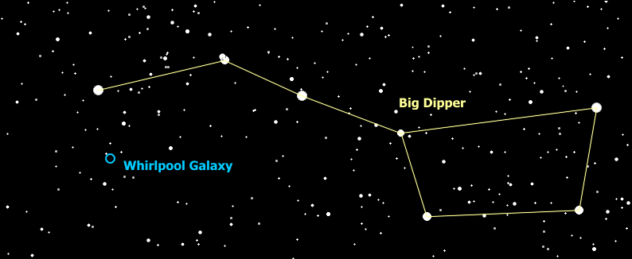

It's actually a pair of galaxies, a big spiral and a small one, connected by one of the spiral arms of the bigger one.



Wow. It will never look this good in our telescope, but just so you know what you're looking at.

# The Constellation Boötes

1. We will now follow the handle of the Dipper and arc to Arcturus, a star in the constellation Boötes (pronounced boo-OH-teez). {Trace out Boötes}. Boötes is a herdsman and the Guardian of the Bear -- Ursa Major. It is usually pictured as a guy just standing there, somtimes with a staff -- you can make the hook of the staff out of the three stars to the north of the kite, just off the end of the Dipper's handle.

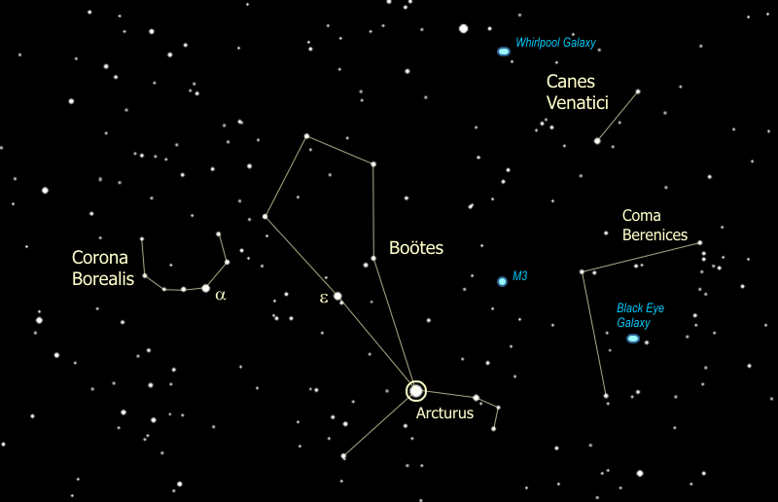

Arcturus is historically famous for a number of reasons. For example it was used to turn on the lights at the 1933 Worlds' Fair in Chicago. They put a telescope on Arcturus, focused the light down to a photocell which then turned on the lights. The reason they did this is that Arcturus is 40 light-years away from us, and the last time the World's Fair had been in Chicago was in 1893, 40 years prior, so the light they were using to start the World's Fair had left the star at the time of the last World's Fair in Chicago. Cool, huh?

1. Note Boötes is a kite-shaped constellation. It used to be a shorter kite -- in ancient Greek & Roman times (2,000 years ago) Arcturus was half the distance closer to the two center stars (epsilon & rho Boötes). It is moving across the sky faster than any other bright star (except Alpha Centauri which is ten times closer) -- it couldn't be seen 500,000 years ago and 500,000 years from now it won't be visible any more. Why is Arcturus moving so fast?

The stars of [our galaxy](Auriga.html#MilkyWay) are formed into a rotating disk and are all moving together around the disk. Some stars -- called "halo" stars -- form a dome over the disk, Arcturus is one of those stars, orbiting above and below the galactic center. It is cutting through the disk now, actually a little bit back against the general flow. Someone on a planet orbiting Arcturus would see the entire night sky changing constantly.

1. Next to Boötes is Corona Borealis, the northern crown. {Trace out Corona Borealis}. The brightest star is a (alpha) Corona Borealis. This star is a member of the Ursa Major Moving Group, as is the lower left "kite tail" star (to the Southeast) of Boötes.
2. To the right of Bootes, just below the handle of the dipper, you can see two stars. The brighter one is called "Cor Carolis" -- it means the heart of Charles (King Charles II). These two stars form the constellation Canes Venatici. If you look carefully you can pick out two faint, scraggly diagonal lines of stars, one of which includes the two stars I just pointed out and the other is just a little above it. These two lines are two dogs on a leash held by Bootes -- this takes a bit of imagination -- and are helping him in his duties as herdsman and guardian of the bear.

# The Constellation Leo

1. We will now return to the [Dipper](file:///C:\Users\randy\MyWebSite\astronomy\Spring\Polar.html#Pointers) and follow the two stars at the back of the cup down, leading us to the star Regulus in the [Zodiac](file:///C:\Users\randy\MyWebSite\astronomy\Spring\Gemini.html#Zodiac) Constellation Leo the Lion, which dominates the center of the Spring sky. {Trace out Leo, point out the stars Regulus & Denebola} This is a great constellation that looks very much like what it is supposed to be. Some star charts show Leo walking, but to me the stars powerfully suggest the Big Cat is in a reclining position. His head is formed by a backward question mark, an asterism that is commonly called The Sickle. The star to the right of Regulus is his forepaw, and the bright triangle to the left is the lion's rear haunch.

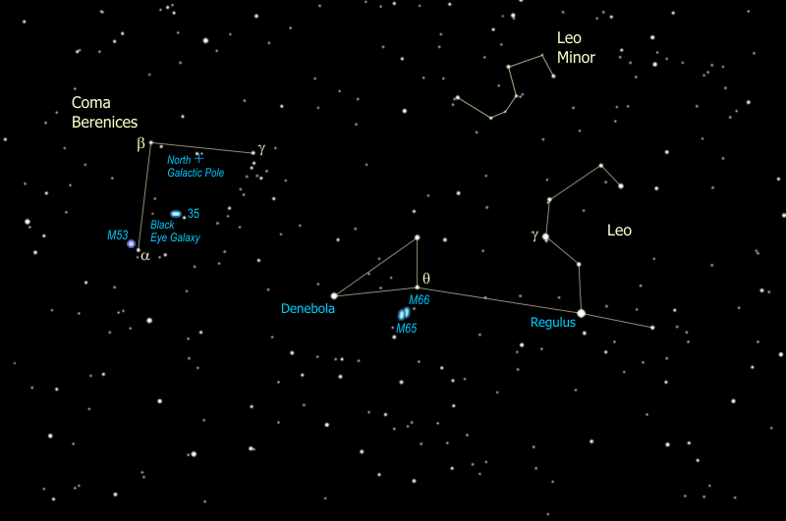

1. You can use the Sickle to gauge how good your sky is... the clearer the sky, the fainter the magnitudes you can see. Starting with 1st magnitude Regulus we skip a star and come to 2nd magnitude g (gamma) Leonis, then as we go up, the back of Leo's head and his nose are both 3rd magnitude stars, and his topknot is 4th magnitude. His eye, half-way between the nose & topknot, is 5th magnitude and if you can see it, indicates you have an excellent sky. His ear is an itty-bitty 6th magnitude star which, if you can see it, tells you that your sky is the best you're going to get.

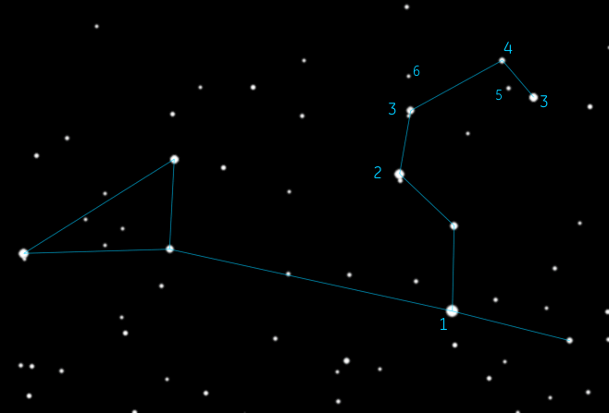

1. Regulus is the brightest star in Leo and is sometimes known as the Heart of the Lion, "Cor Leonis". If you can get the binoculars focused on this star you'll find a surprise waiting there for you... up and to the right -- a fainter, golden yellow star right next to the brilliant blue-white Regulus. (If the sky isn't dark enough we might have to use the telescope to see it.) The fainter star is in orbit about Regulus, and in fact that fainter star is really two stars, too close for us to resolve, a yellow dwarf and a red dwarf. So you are looking at a three-star system. That may seem weird to you, three stars locked in orbit together, but in fact three quarters of the stars you see up there have at least one, maybe two or more companions. So we're the weird ones, circling a single solitary star -- the sun.
2. Meanwhile we've gotten the telescope on another double star, one you can only see with the telescope. We are looking at g (gamma) Leonis, a pair of stars 90 light years away and circling each other at a distance about three times the size of Neptune's orbit.

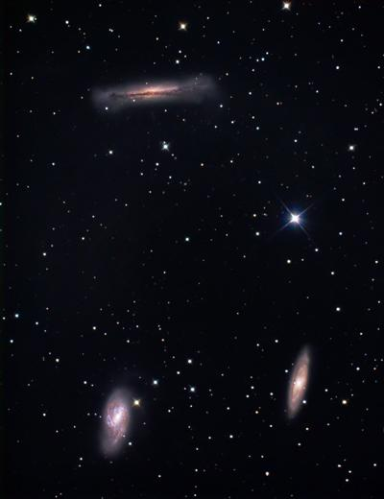As you look at this pair you might notice a tiny little ring around each star. This is a "diffraction ring" -- it's an interference pattern caused by light waves interacting with the edge of the telescope opening. Note: this is assuming I'm using my 90mm telescope at 90x magnification, a larger telescope or lower power will likely not show the diffraction rings. When you can see these rings, that's a sign that you have reached the limit of the detail your scope can show. You might be able to get to an even higher magnifying power, but you won't see any more detail. The image will only get fuzzier and darker.

1. Leo is, as I said, a Zodiac constellation, so as we circle around the sun, it seems to pass through this part of the sky. In fact Regulus lies almost directly on the ecliptic, meaning it lies right on the plane of our solar system. As a result, it is fairly common to see the moon and planets pass very close to Regulus, and sometimes right in front of it, blocking out the star!
2. Since he's in Galaxy Alley, Leo has quite a few galaxies of his own. If we have a dark night you can look with the binoculars just south of q Leonis and detect the very close pair of galaxies, M65 & M66. With the telescope we can see more detail and maybe even see a third galaxy just to the north of this bright pair, NGC3628. These three galaxies are a well-known group called the Leo Trio, a true grouping, all about 30 million light years away.
3. Just above Leo, a little to the north, is Leo Minor, which is usually shown as just a flat triangle of the three brightest stars. But if you have a reasonably dark night and can see the dimmer stars, you can see the figure as drawn above, which gives you a little more of a clue of why on earth somebody ever called this "Leo Minor". You can actually see a miniature reflection of the figure of Leo in these fainter stars.
4. To the left of Leo you might be able to see a wispy collection of faint stars, which could very well be the tuft of the lion's tail. In fact at one time that is precisely what those stars were considered to be, before they became a constellation of their own, known as Coma Berenices or "Berenice's Hair". {Trace out Coma Berenices, showing the right-angle stand and the hair hanging from it.} This wisp of stars is a true cluster, and one that is very close to us. At 250 light years, only the Hyades and the Ursa Major moving group are closer.
5. Coma Berenices is the home of the galactic north pole, just a nudge below that star half-way between b and g, a star known as "31 Comae Berenices". What that means is that when you're looking at Coma Berenices you are looking directly up, out of our galaxy. It also means that when Coma Berenices is straight up in the sky, the Milky Way can't be found anywhere in the sky, because it is circling you, following the horizon all the way around you.

Coma Berenices lies right in the middle of the Virgo cluster of galaxies, and in fact contains so much of the cluster that it is often referred to as the "Virgo-Coma Cluster". One of the best is the Black Eye Galaxy, just to the left of that little star right there {point out 35 Comae}. You can spot it with the binoculars, although we need a relatively large telescope (8" or better) to see the black eye at the center. It's actually a lane of dust that is the result of a collision with another galaxy -- literally smacking into this one and leaving it with a black eye.

1. Now, if you look with the binoculars just slightly above and to the left (northeast) of a Comae Berenices you will find a faint fuzzy spot -- this is M53, from Messier's catalog, and once we get a telescope on it you will discover it's one of the treasures of the deep sky. This is not just any star cluster -- notice how it looks like a little globe of stars? For that reason this kind of cluster is called a "globular cluster".

Globular clusters are rare - only about 150 are known, and they are completely different from open clusters like [M35](file:///C:\Users\randy\MyWebSite\astronomy\Spring\Gemini.html#Open) that we saw in Gemini.

M35 is estimated to be about 100 million years old, while M53 is estimated at about 10 BILLION years old, making it so old that it formed before the disk of the Milky Way galaxy formed! While M35 has several hundred stars in total, M53 has several hundred *thousand* stars. M35 is about 3000 light-years away and about 30 light-years across, M53 is 60,000 light-years away and 220 light-years across.

These numbers are typical, so globular clusters are much, much bigger than open clusters, and they are much, much older - some are nearly as old as the universe!

1. Coma Berenices is the only constellation in the sky whose legend is actually based on a true historical incident. The story goes back to about 200 years BC, in ancient Egypt. The king of Egypt at that time was Ptolemy, a shrewd king who ruled well, advanced Egyptian influence in the world and along with his father, established the library at Alexandria, an enormous achievement both culturally and for the academic world.

But when the Assyrians murdered his sister, Ptolemy headed up an army on a mission of revenge. The Assyrians had a chilling reputation for ferocity, a reputation that has stayed with them right up to the present day. So Ptolemy's beautiful queen, that would be Berenice, made a promise to Aphrodite, the goddess of beauty, that if Ptolemy came back safe from his raid, she would cut off her long flowing hair and offer it to the gods.

The king did indeed return from the sortie in one piece, the queen did indeed cut off her hair and place it in the temple, and the hair was promptly stolen that very night. The king and queen were furious and the temple guards, having slipped up, were on the brink of being put to death when the court astronomer saved them through some quick thinking. Possibly already aware of the asterism behind Leo that resembles a tuft of hair, he announced that Aphrodite was so pleased with the gift that she had taken the offering and placed it among the stars. Incredibly, the king bought it, and the guards were spared.

So the moral is -- study your astronomy. You never know whose life you may save.

And on that note, our tour of the Spring night sky is completed. In early spring we may have spent some time early on picking up some of the more spectacular gems of the [retreating winter titans](file:///C:\Users\randy\MyWebSite\astronomy\Spring\Titans.html). In late spring, we have Hercules and Lyra on the rise, with the spectacular globular cluster M13 and the best planetary nebula in the sky, the Ring Nebula, as described in the [Summer Sky Tour](file:///C:\Users\randy\MyWebSite\astronomy\Summer\summer.html), which the more robust stargazers might stick around to see. At this point, though, we've covered quite a bit of ground and it's usually just to about time to call it a night.

# Tell Time by the Big Dipper



Using the Big Dipper to tell time (by the line from the pointer stars to Polaris) is easy.

* It's a backwards (counter-clockwise) running 24-hour clock, because the earth turns west to east a full turn every 24 hours, and
* It runs fast. Due to the earth's yearly orbit around the sun, it gains 24 hours each year.

So to use the clock you only need to do two things.

* Remember the 24-hour clock face, shown above, and
* Adjust the 24-hour (midnight) mark on the clock to the current date. 24 hours in 12 months is two hours every month, so shift the midnight mark up by two hours (counter-clockwise) on the clock each month, or a half-hour each week. Some key dates to remember are shown on the drawing.